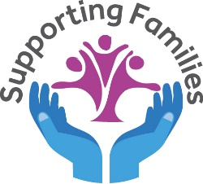
Parent /Carer forum

The Parent’s Forum is made up of a group of local Parents/Carers who regularly meet each term. They have a valuable input in the planning of upcoming events and activities for children and their families in the Family Hub.

The Parent forum makes sure that views of parents and carers are heard, they can share opinions and ideas about issues that may affect families in our community and they co-design and co-produce upcoming service offers.

The Parent forum also offers a great opportunity to meet other Parents/carers and share ideas.

If you would like to have YOUR SAY, then why not join us for a friendly informal discussion to find out more:

Please contact Lori Brookes on the telephone number below:

Southglade Access centre
Southglade road
Bestwood
NG5 5GU
0115 8761890


All MUMS, DADS, GRANDPARENTS AND CARERS welcome!

